**IMPLEMENTING CRM FOR RESULT TRACKING OF A CANDIDATE WITH INTERNALMARKS**

**ProjectReportTemplate**

**INTRODUCTION**

* 1. **Overview**

Administrator should be able to create all base data including semester, candidate,course and lecturer, lecturer should have the ability to create internal results, dean, who isone of the Lecturer, should be the only one with ability to update internal results, re-evaluationcanbeinitialisedbycandidate forallinternalresults.Nowonlydeancanupdatethemarks afterre-evaluation.

* 1. **Purpose**
     + It helps you in collating all the customerinformation at one place and helps youin bettercustomermanagement.
     + Awantisplacingcertainpersonalcriteria astohowthatneedmustbefulfilled.
     + Itiseasywaytomaintaininternalmarks.

# PROBLEM DEF**INITION&DESIGNTHINKING**

* 1. **EmpathyMap**



**2.2 Ideation&Brainstorming Map**



# **RESULT**

**3.1 DataModel**:

|  |  |
| --- | --- |
| Objectname | FieldsintheObject |
| SEMESTER | FIELDLABEL:  Semestername  Course(Lookup)  DATATYPE  Text |
| CANDIDATE | FIELDLABEL  Candidate NameCandidate IDSemesterName  InternalResult(LookUp)DATATYPE  Text |
| COURSE DETAILS | FIELDLABEL:  Course NameCourseID  DATATYPE  Text |
| LACTURERDETAILS | FIELDLABEL  Lecturer RoleLecturer NameCourseIDCourse(Lookup)  DATATYPE  Text |
| INTERNALRESULTS | FIELDLABEL  Candidate IDCourseID  Marks |

|  |  |
| --- | --- |
| C:\Users\ELCOT\Pictures\Screenshots\Screenshot (13).png | DATATYPE  Text |

**3.2 OBJECTS**

W

Wehavecreatedandeveloperaccount forsalesforceaccount.Salesforce isyourcustomersuccessplatform

Our mailidandnamearegiventogetdeveloperaccount.

CUSTOM OBJECT

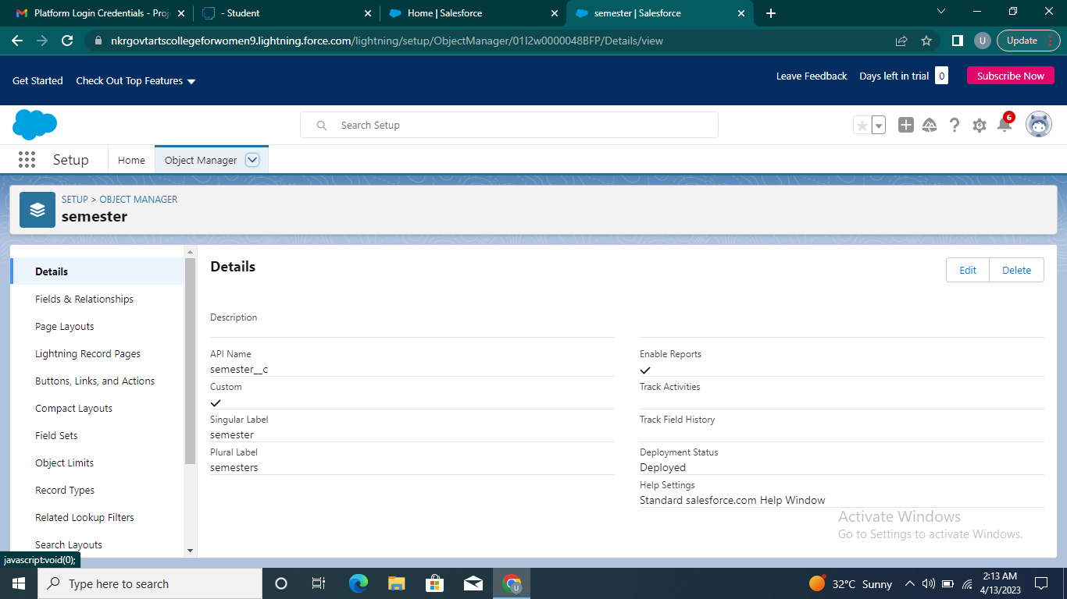

TAB:

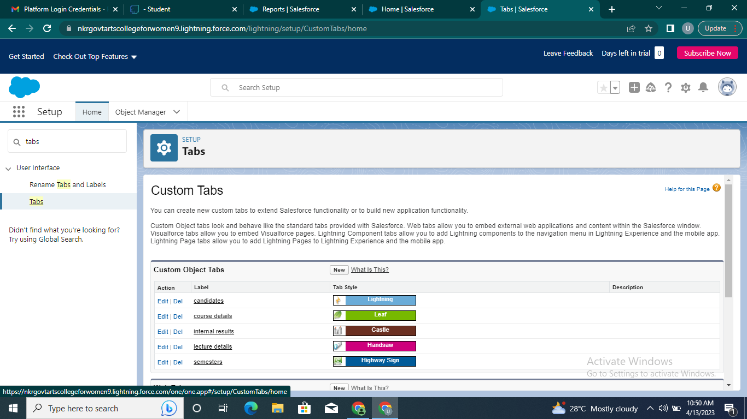

creation of objects for candidate internalresultcard,forthiscandidateinternal

resultcard wasneedtocreate5 objectsthatareSemester,Candidate,CourseDetails,LecturerDetails,InternalResults.

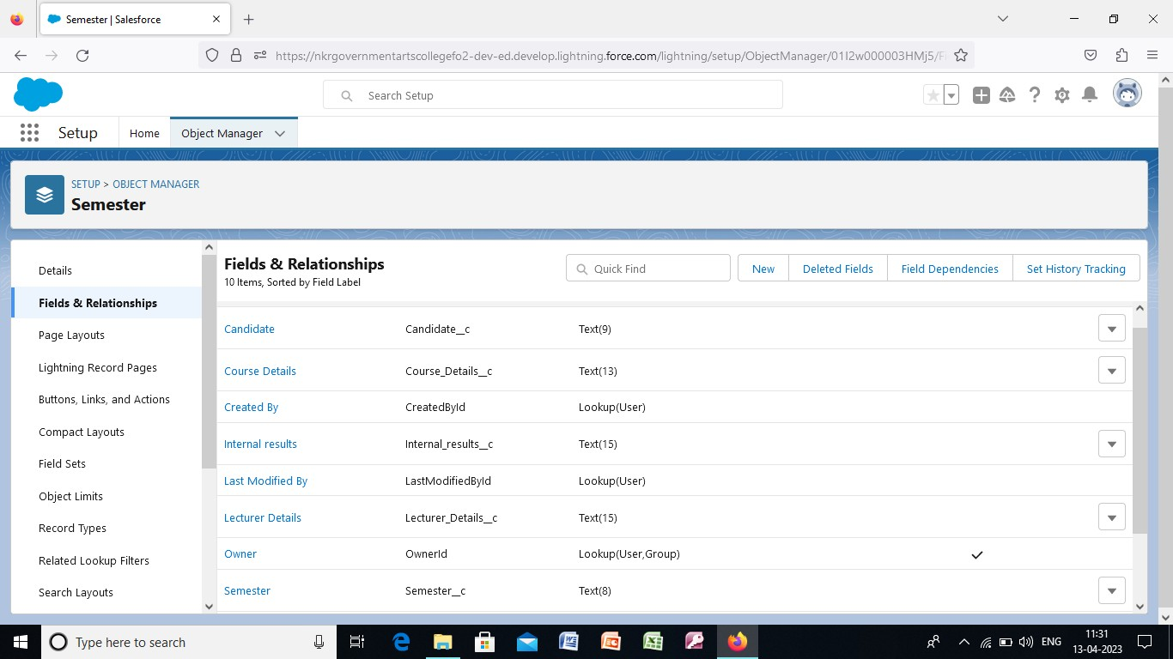**3.2 fields& realationship**

Relationshiparecreatedcustomrelationshipfieldsonan object.Thisisdonefortheuserstoview,records,theycanalsoseeandaccess relateddata.

**3.3 LIGHTNING APP**

CREATE THE CANDIDATE INTERNAL RESULTCARD APP

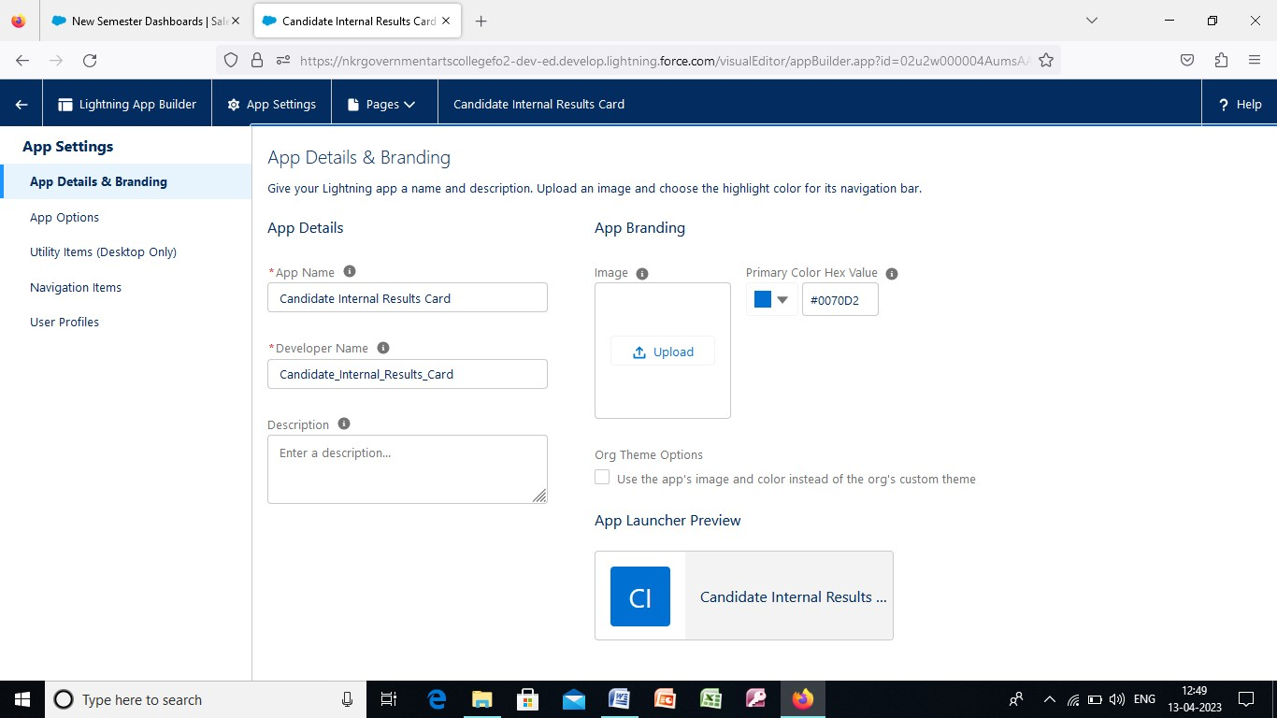

App in Salesforceareagroupoftabsthathelp theapplication functionbyworkingtogether as a unit.We have created the lightning app of candidate internal resultcard.

**3.4 USERS**

CREATING A USERS

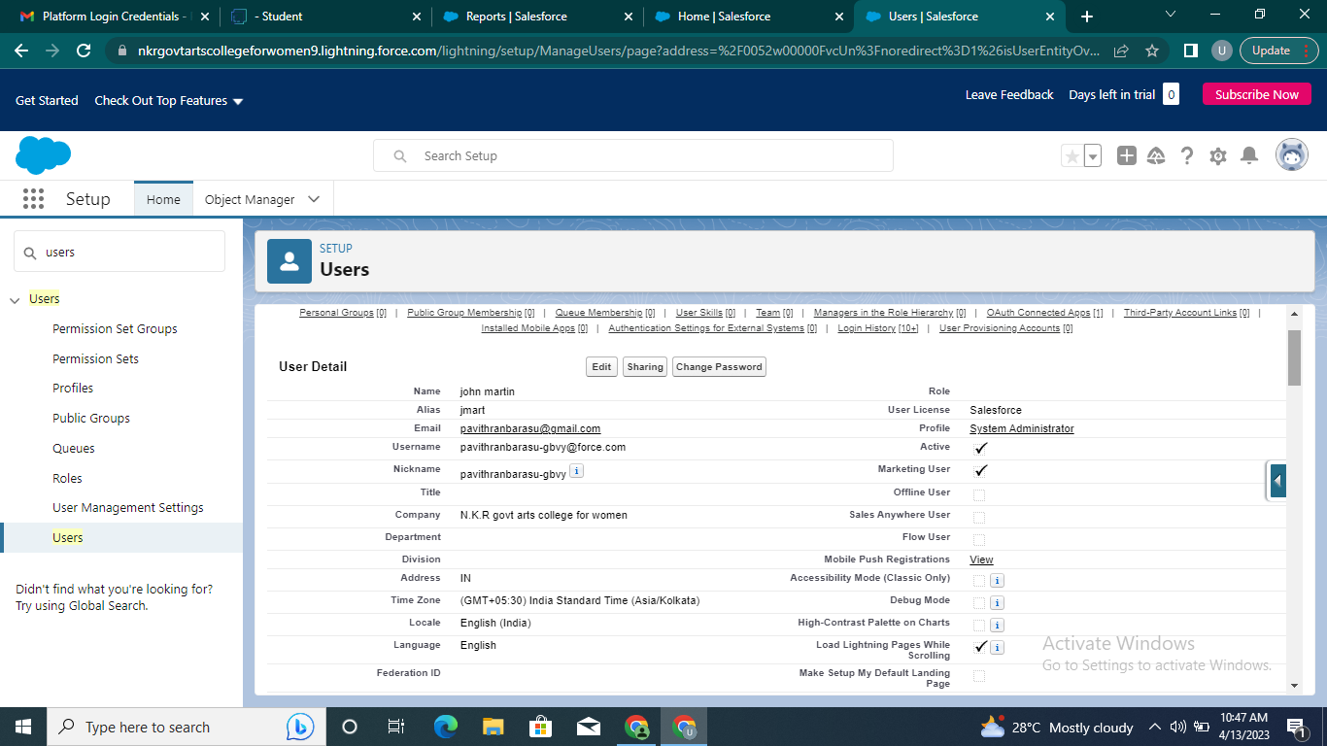

Every user in salesforce has a user account.Click setup enter user , enter thedetails,wecreateanewuser.

## 3.5 REPORTS

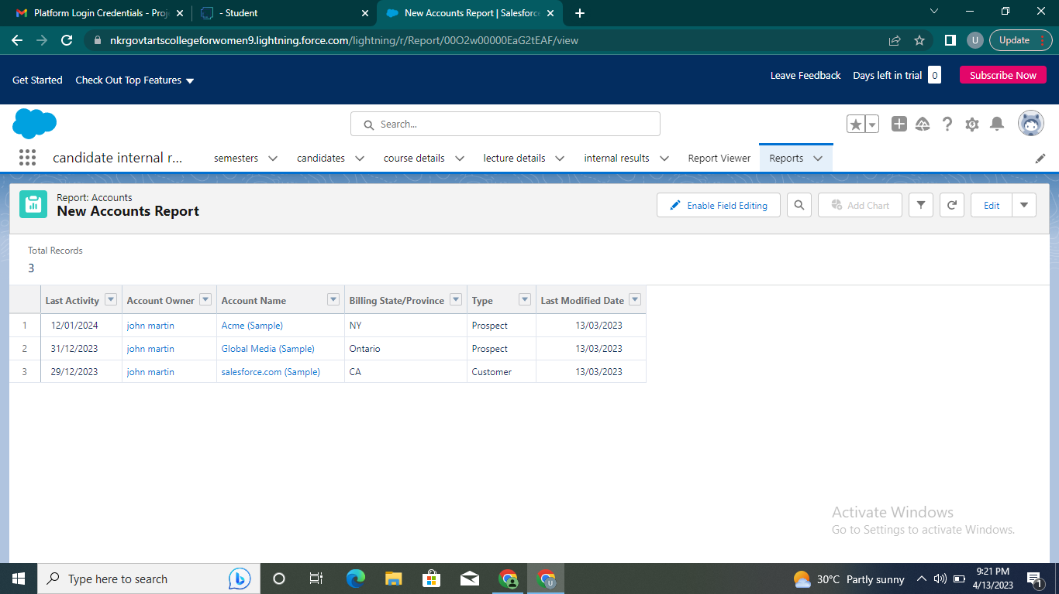

A report is a list of records that meet the criteria you define.Its is displayed insalesforce in the form of rows and columns, and can befiltered, grouped, ordisplayedinagraphicalchart.Everyreportsisstoredinafolder.

3.6 DASHBOARDS

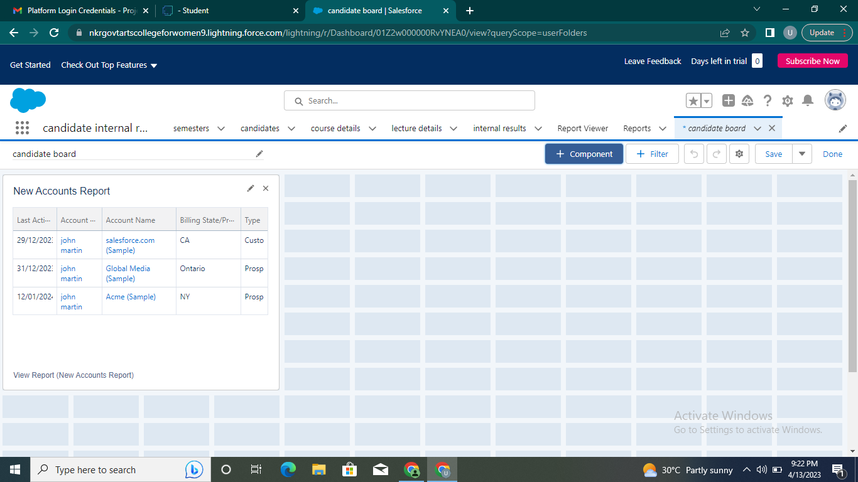

**4.TRAILHEAD PROFILEPUBLIC URL**

Team Leader:

http://trailblazer.me/id/apavithra16

Team Member 3:

https://trailblazer.me/id/priys80

http://trailblazer.me/id/uyasothap

https://trailblazer.me/id/uashwinir

ADVANTAGES

* CRMmadetargetingand marketingsimple
* Improvedevisionmakingandproductivity
* Trackingofcustomerdata.
* Customerareengagedacross multiplechannel.

DISADVANTAGE

* Lossofcollectedinformationorrecords.
* Notsuitableforeverybusiness.
* Experiencebasedinallthestages.
* Centralizeddataisatstake.
* lotsofsecurityconcerns.

**6.APPLICATIONS:**

Thisapplicationisusedbythe governmentagencyorvisaprocess7CONCLUSION:

This concluded, that the existing Implementing CRM for result tracking ofcandidatewith internalmarksbecamesmoreresultweaddthistypeoffeaturewiththehelpofsalesforce.

8FUTURESCOPE:

We see the Future scope of this Project would save that time of both peopletheapplicantsandtheRecrultess.